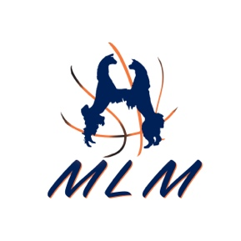
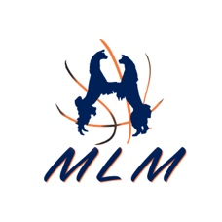
March Llama Madness
Prospect Futurity & Sale of Champions

Buyers Number Form

Name: ________________________________________________________________________
(Please Print)

Farm Name: _________________________________________________________________________________
(How you want the llama transferred)

Address: ______________________________________________________________________

City, ST, Zip Code: ______________________________________________________________

Phone Number: ________________________________________________________________

Email: ________________________________________________________________________

Driver’s License Number: _________________________________________________________

Do you want to be on the phone with a staff from Darrell Anderson Auctioneering Company when bidding? Yes____ NO____

Will you have a friend doing the bidding for you, if yes, name of your representative? Yes_____ NO_____ Name of representative _____________________________________

Please fill out and scan, email to merlenea55@gmail.com or dmand531@gmail.com

Take a picture and text to 765-426-3547 or send in Facebook Messenger.

Thank you,

Darrell Anderson

