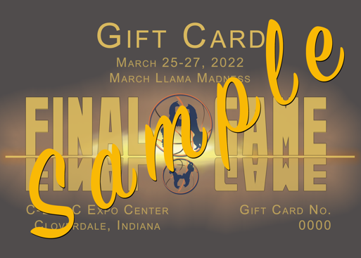
To: ____________________________________________
From: __________________________________________
Message: _______________________________________
_______________________________________________

Name: ________________________________________________________________________
Address: ______________________________________________________________________
City ____________________________ ST _______________________ Zip _________________
Email Address: _________________________________________________________________
Phone: _______________________________________________________________________

Please contact us to start the process in getting your Gift Card.
Text or call - Merlene ‘s Phone: 765 426 3547
Darrell’s Phone: 765 427 8551
Email: merlenea55@gmail.com or dmand531@gmail.com
Facebook Message - Person Message

PLEASE PRINT OUT AND COMPLETE IF YOU ARE USING A CREDIT CARDS
MasterCard, Visa and Discover accepted with a 5% processing fee

Name on Card: ________________________________________________
Address Assigned to Card: ______________________________________________
City: ______________________________________________ St: __________ Zip: ___________
Phone Assigned to Card: _______________________________________
Credit Card Type: _____ VISA _____ MASTERCARD ______ DISCOVER
Credit Card Number: ________ - ________ - ________ - ________
Expiration Date: ________ / ________
Card Identification Number (last 3 digits located on the back of the credit card): ________
5% Processing Fee: _________________
Total Amount Charged: $______________
Signature: ____________________________________

MAIL TO: DARRELL ANDERSON
2440 N 650 W
WEST LAFAYETTE, IN 47906

